(Approx. 1,535 words)

Tablets for Mobile Computing – New to some; Useful for most
By Phil Sorrentino, Member, The Computer Club, Florida
November 2014
http://scccomputerclub.org
Philsorr.wordpress.com
philsorr (at) yahoo.com

When most of us think about Mobile Computing, we probably think of Laptops. Laptops are relatively light making them fairly portable, and are battery operated, making them just right for mobile computing or computing “on-the-go”. Now that Tablets have come on the scene, it appears that they may be ready to take over some of the computing tasks previously done by laptops. Why, you may ask. Well, tablets are lighter than laptops, and they typically have a battery that allows for operation two to three times that of a laptop, usually enough for a full days work. If you are new to the thought of using a tablet for some of your “on-the-go” computing tasks, let’s take a look at how a tablet might contribute. It is true, that the tablet does not have a Hard Disk Drive or an Optical Disk Drive, so the computing tasks for a tablet have to be able to be accomplished without these two resources. But, as it turns out, there are quite a few tasks that can easily be done with only the resources of a tablet, for example, checking your email, checking your calendar, Googling something, viewing pictures and videos, reviewing spreadsheets or documents, playing music, checking the weather report, checking your stock portfolio, reading the news, shopping on the internet, sharing comments and pictures on Facebook, and sending a tweet on Twitter. All of these things can easily be accomplished using an Apple iPad, an Android tablet, or a Microsoft Windows 8 tablet.

If you think a tablet might be the way to accomplish some or all of these “computing on the go” tasks, let’s look at how to get started with your tablet. All the three aforementioned tablets can do the job, but there are differences and the differences are in the details. Android tablets have over 65% of the market, so I’ll use an Android tablet for the details. Tablets, on the surface, are pretty simple devices. There is a screen, and a few basic controls. The first thing to do is to become familiar with these very few controls. Most of them are around the rim of the device. The power On-Off button is used to both turn the power on and off and also to turn off the display when you don’t want to drain the battery. With the tablet on, a short press of this button will turn the screen off; a long press (approx. 4 sec.) will allow you to turn the tablet off. If the screen ever goes off when you are using the tablet, just touch the power button and the screen will immediately come back on. The other control is a Volume Up-Down rocker button, used for volume control and sometimes other functions depending on the App that is running. We’ll get to Apps in a moment. You might find another button or so, possibly a “back” button, but the tendency is to have fewer hardware buttons and to make do with buttons that show up on the screen; software buttons. Two software buttons will show up on the screen (after the tablet has been turned on), usually at the bottom. These are the Home and the Back buttons. The Home button will bring you back to the home screen you started with, and the Back button will bring you back one step in whatever App you are running. (Yes, we are going to get to Apps.) The Home and back buttons typically look like this:

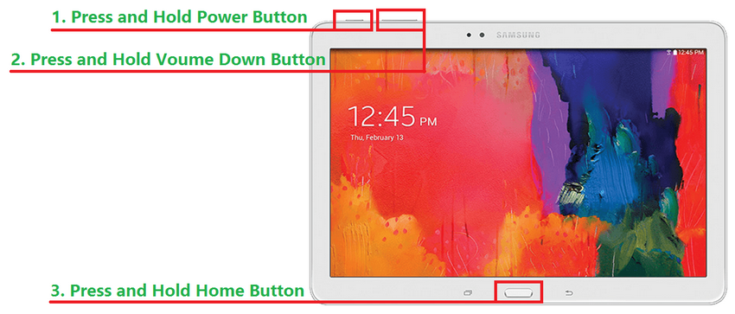

Once you have found all the controls, turn on the device and wait for the home screen. There will probably be 3 or 5 screens available, but typically the one in the center will be the home screen (the screen that comes up on initial power-on). This screen may have only a few or it may have many icons, depending on the manufacturer. Each icon is a short-cut to an App. The term “App”, which is short for application, is used for most of the software programs that you will run on your tablet. (Don’t complain to me, I’m only the messenger. Apple coined the term and it seems to have stuck.) Actually, you may also see the term “widget”. Widgets are like Apps only they show changing data in their Icon. (Think about a “Weather Widget”, which constantly shows the temperature and weather outlook for a given location, or a “Finance Widget” that constantly shows the Dow Jones average.) But, most of your interaction with the tablet will be through Apps.

Now, there are a few Icons that are extremely important. The most important icon, in my opinion, is the icon that lets you get to the store to acquire new Apps (most are free but some come at a cost). Most Android tablets will have the Google Play Store icon. Amazon tablets, like the kindle fire HDX, will have the Amazon Store icon (even though they use the Android Operating System). These two different icons take you to two very different locations on the internet. Shown here are the Google Play Store and Amazon Store Icons:
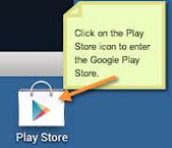
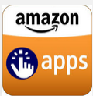

Google Play Store Amazon Store

Another very important icon is “Settings”. The Settings Icon gets you to the settings App which provides information about the tablet and provides controls to set the general operations of the tablet. Settings icons may be different on different tablets, but shown here are two popular Settings icons:

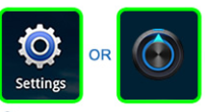

The next most important Icon is the “All Apps” Icon. This Icon will typically be on the home screen, and possibly show up on all screens, and is usually in the upper right corner, or at least somewhere on the right side of the screen. This Icon gets you to the “All Apps” collection. This is where you can find all of the Apps that have been installed on your tablet. Touch this Icon for an alphabetically listed view of all of your apps. There are also a few different “All Apps” Icons. Shown here are a few examples:

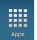
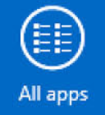
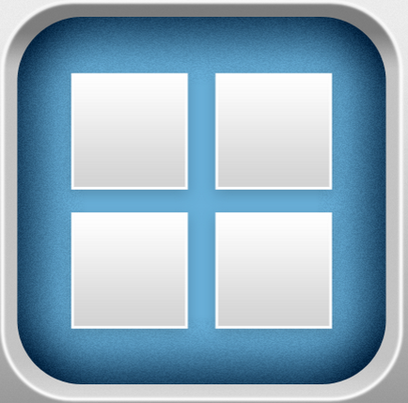

Tablets are useful and fun to use, once you have set them up with the Apps that you want to use. The only way to get Apps on to your tablet, beyond the Apps that come with the device, is to download them from the Google (or Amazon) store, (which is somewhere out there on the Internet). On most tablets, the only way to get on to the internet is via Wi-Fi. (A few, more expensive, tablets also have the capability to get on to the internet via the cell phone system. This allows them to get on to the internet wherever their cell provider has coverage.) Without a connection to the internet the tablet would just be an old fashioned Personal Digital Assistant. In order to get on to the Internet we have to set up the Wi-Fi. In order to set up the Wi-Fi we need to get into the Settings. (Now you see why Settings is a very important Icon.) So, find the Settings Icon and touch it. The settings screen is split in two. The left side is for navigation, and the right side expands whatever was selected on the left side. Usually, Wi-Fi is the first entry on the left under “Wireless & Networks”. If Wi-Fi is not on, touch the switch and turn it on. With Wi-Fi selected on the left, the possible Wi-Fi networks will be shown on the right. Select the network you plan to use and then provide the password if needed. (If the little icon next to the network name has a lock on or near it, a password will be needed. If there isn’t a lock on or near it, the network is open and does not need a password.)
Once you are connected to a network you should see “Connected” under the name of the network you are using. Touch the “Home” software button to get back to the home screen.

Now that you are connected to a network, the internet is your oyster. You can use a browser to generally browse the internet or you can use your Apps to get specific kinds of information from specific websites. One of the first things to do is to go to your store and download something you want or just something for practice. When you get to your store, look for an App that sounds interesting and try to download it. Maybe an email App, or a game like Candy Crush, or Sudoku, it will be good practice and maybe even fun. Basically, touch your “Store” icon, then touch the “Search” icon (usually at the top on the right) and type in the App name. Select the Apps icon and then “Accept” the permissions and watch it install.

Once the App is installed, you can start to take advantage of some of the benefits of having a tablet, like checking your email, or reading the news, on the go. This might just make you feel that your tablet is useful for mobile, on-the-go computing.

